EXPERIMENT NO: 1 DATE: / / 20

AIM: To study various electronics and electrical symbols.

THEORY:
Graphic symbols are used to denote electrical, electronic and mechanical components and devices. They are used to portray complex schematic and wiring circuit diagrams in a simple manner for conserving space. In order to make the diagrams easier to read, the graphic symbols, in many cases, resemble the actual component or its element. Thus, the graphic symbols serve as effective & precise means of communication, particularly in situations, which involve complex diagrams and devices.

We have selected a few commonly used symbols and have explained them first and the symbols are drawn in the latter part.

FUSE:
Many circuits have a fuse in series as a protection against over load from a short circuit. Fuses are fabricated from low melting point alloys. Under normal load conditions, the current through the fuse will not produce excessive heat. If the circuit is overloaded or if a fault occurs, leading to a heavy rush of current, the fuse element melts due to high heat generated by this increased current. This blowing-up of the fuse thus opens the series circuit. The objective is to let the fuse blow before the components are damaged. A new fuse element can easily replace the blown fuse after the overload has been eliminated. Fuses are manufactured in a wide variety of shapes & current ratings. Fuse elements are made of tin-coated copper or nickel and aluminium. They are available in current ratings of 2 mA to hundreds of ampere.

CELL & BATTERY:

A voltaic chemical cell is a combination of materials, which produce direct current (DC) from its internal chemical reactions. Each cell has two terminals +ve terminal & –ve terminal.

An electric battery consists of a number of electro-chemical cells, connected either in series or parallel. The voltage rating of battery depends upon voltage rating of group of cells (either connected in series or parallel). The voltage rating of cell is given by its open circuit voltage i.e. voltage it can produce when not connected to a load circuit. This voltage depends on the type of materials used and not the physical size of the cell.

SWITCHES:
A switch is a device for opening and closing a circuit. They are manufactured in hundreds of sizes and types. Some of the more common ones are discussed below:

- Single pole Single – throw (SPST) Switch:
Such switch has one lever or arm (i.e. Single pole). It can connect or disconnect one side of a line or a single wire circuit.
Example: Tumbler switch, piano switch using in house wiring, etc.

- Single pole Double – throw (SPDT) Switch:
Such switch has two ON positions. It is OFF when in the centre. As schematically shown in fig. it has one are (hence Single Pole) but can be moved into either one of the two positions. Obviously, it can close either one of the two circuits.
Example: blunder switch OFF & ON (Low speed, High Speed).
- Double pole Single throw (DPST) Switch:
Such a switch has only one position of closure but completes two contacts simultaneously. It fact it is similar to SPST switch except that it switches both sides of a wire line at once. It may also be used as two single pose switches acting together.
- Double pole Double throw (DPDT) Switch:
Such a switch has two poles and can be moved either to the right (Position A) or to the left (Position B).
- Rotary Switches:
The best example of such a switch is the switch used in ceiling fan regulator. The symbol drawn is for a single pole rotary switch.
- Push Button:
Symbol is shown in fig. It is like a switch with a spring return system i.e. when button is pressed it makes contact or release contact as the case may be. When released it comes back to its normal position. [NC or NO]

RESISTOR:

It is passive element. A resister is an electrical component with a known specified value of resistance. It is probably the most common component in all kinds of electronic equipment ranging from a small radio to a colour television receiver. As its name suggests, a resistor opposes the flow of current through it. Resistance is necessary for any circuit to do useful work. In fact without resistance, every circuit would be a short circuit.
Some of the common uses of resistors are: -
- To establish proper value of circuit voltages due to IR drops.
- To limit current.
- To provide load.
Resistor can be connected in the circuit in either direction because they have no polarity. The types of resistor are:

- Fixed Resistor:
It is such resistor, where we cannot change its resistance value.
- Variable Resistor:
It is such resistor, where we can change its resistance value.

- Rheostat:
One type of variable resistor which has two fixed terminal & one variable terminal or known as wire wound resistor they are constructed from a long fine wire i.e. high resistance wire (Nickel chromium wire) wound on a ceramic core. The advantage with a rheostat is that it can be used as a fixed resistor as well as a variable resistor.

INDUCTORS:

It is another passive element commonly used in electrical/electronic circuit It is nothing but coil wound on a core or former of some suitable material. It opposes any change in current. There are mainly two types of inductors on basis of their construction
- Air Core Inductor:
It consists of number of turns of wire wound on a former made of ordinary cardboard. Since, there is nothing but air inside the coil it is termed as an air-cored inductor. It has the least inductance for a given number of turns & core length.
- Iron-Core Inductor:
It is that inductor in which a coil of wire is wound over a solid or laminated iron core. This construction leads to increase in its inductance as many times as the relative permeability (μr) of Iron.

CAPACITORS:

A capacitor has two plates separated by dielectric medium. It is also passive element commonly used in electric circuit. It is a device which
- Has the ability to store charge which neither a resistor nor an inductor can do.
- Opposes any change of voltage in the circuit in which it is connected.
- Block the passage of direct current through it.
They are mainly of two types:
- Fixed Capacitor
- Variable Capacitor

TRANSFORMER:

Basically transformer is power transformation device. It transfers power from one circuit to other either by increasing voltage level (decreasing current level) or by decreasing voltage level (increasing current level) i.e. It makes it possible to step up a relatively low generated voltage level to the possible most desirable high voltage (Step up transformer Np < Ns) or lower the voltage level for most convenient utilization level [esp. in home] (step down transformer Np > Ns).
Its principle’s based on mutual inductance principle. Normally transformer has two windings, which are electrically isolated & magnetically coupled.

AUTO TRANSFORMER:

It is also one type of transformer but in this there is only one winding, which works as primary as well as secondary winding. It is also known, as variac.

TRANSISTORS:

Basically consists of two back-to-back P-N junctions manufactured in a single piece of a semiconductor crystal. These two Junctions give rise to three regions called emitter, base and collector. In fig, the arrowhead is always at the emitter (not at the collector) and in each case its direction indicate the conventional direction of current flow. For a PNP transistor, arrowhead points from emitter to base meaning that emitter is positive with respect to base (and also with respect to collector). For NPN transistor, it points from base to emitter meaning that base (and collector as well) is positive with respect to emitter.
- N-P-N Transistor:
In this P-type material is sandwiched between two layers of N-type material. Normally used for voltage Amplification in amplifier. The symbols employed for PNP is shown in fig.
- P-N-P Transistor:
In this N-type material is sandwiched between two layers of P-type material. The symbols employed for NPN is shown in fig.
- FET:
Nowadays field effect transistors are rapidly replacing both Vacuum tubes and junction transistor, in applications requiring high input impedance.

SEMICONDUCTOR DIODE:

Known as PN junction diode two terminal devices consisting of P-N Junction formed either in Ge or Si crystal. PN Junction diode is one-way device offering low resistance when forward biased and behaving almost as an insulator when reverse biased. So used for rectifier for converting alternating current into direct current. It cannot work in reverse bias condition.

ZENER DIODE:

It is also a P-N Junction but its doping (impurities level) is high as compared to PN Junction diode. So during junction formation in reversed biased condition, its depletion region gets decreased and so at low value of break down voltage it will break and work as constant voltage source. Also, its junction is formed at very high temp so it can withstand large heat produced during reverse biasing without damage. It can work in reverse bias while PN junction does not work in reverse bias. Its uses are:
- As a voltage regulator.
- As a fixed reference voltage in a network for biasing and comparison purposes and for calibrating voltmeters.

WATTMETER:

It measures electric power. They are of AC type & DC type
AC Power = VICosΦ Watt [Cos Φ – Power factor]
DC Power = VI Watt

It has two coils - one, which is known as current coil designated with M. & L. Second coil known as potential coil designated with C.V.
- Current coil always connected in series with circuit, as it measures current of Circuit.
- Voltage coil or potential coil is connected in paralleled to circuit as it measures Voltage of coil.
Combined it measures power of circuit.

CROSSOVER:

Symbol is as shown in fig. It means two wires are not meeting at a point.

JUNCTION:

Symbol is shown in fig. It means two wires are meeting at a point.

DC GENERATOR:

Function of generator is to convert mechanical energy into electrical energy. DC generator is based on dynamically induced e.m.f. principle. In this generator output electrical energy is in term of DC so it is called DC generator.

AC GENERATOR:

Converts mechanical energy into electrical energy. Electrical energy produced is an alternating quantity and hence called an AC generator. It operates on statically induced e.m.f. principle.

DC MOTOR:

Function of motor is to convert electrical energy into mechanical energy. Its input electrical energy is in form of direct quantity so it is called DC Motor.

AC MOTOR or INDUCTION MOTOR:

Converts AC electrical energy into mechanical energy.

SYMBOLS:
DESCRIPTION | SYMBOLS

Fuse
Cell/Battery | 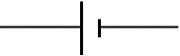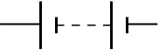

Switches
- Single pole single throw [SPST]
- Single pole double throw switch [SPDT] | 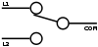
- Double pole single throw switch [DPST] | 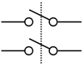
- Double pole double throw switch [DPDT] | 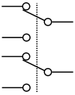
- Rotary switch | 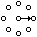
- Push button switch [NO & NC] | 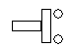N.O. 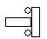N.C.
Resistors
- Fixed resistors | 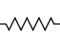
- Variable resistors | 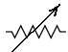
- Rheostat | 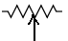
Inductors
- Fixed inductor or air core inductor
- Variable inductor | 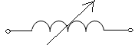
- Iron core inductor | 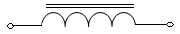
Capacitors
- Fixed capacitors
- Variable capacitors | 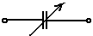
Transformers
- Iron core transformer | 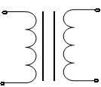
- Auto transformer | 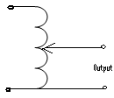
Transistors
- N-P-N transistor | 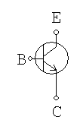
- P-N-P transistor | 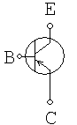
- FET [Field Effect Transistor] | 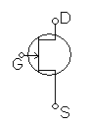
Diodes
- P-N junction diode | 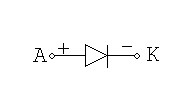
- Zener Diode | 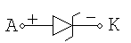
Meters
- Ammeter | 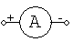
- Voltmeter | 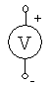
- Wattmeter | 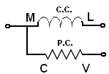
Network
- Junction | 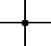
- Crossover | 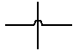
Motor / Generators
- AC Motor | 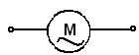
- DC Motor | 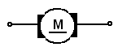
- AC Generator [alternator] | 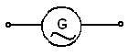
- DC Generator | 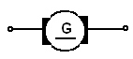

Conclusion:

EXPERIMENT NO: 2 DATE: / / 20

AIM: To perform Kirchhoff’s Voltage Law [KVL]

APPARATUS: Network theorem kit, DMM, connecting wires

THEORY:

KVL- KIRCHOFF’S VOLTAGE LAW:

Kirchhoff’s voltage law states that algebraic sum of all branch voltages around any closed loop of a network is a zero at all instant of time or we may say that around any closed loop, at any instant of time, the sum of the voltage drops must equal the sum of the voltage rises.

PROCEDURE:

KVL
- Once the current is measured as directed, measure the voltage across each resistor with the help of multi-meter.
- Verify the KVL for close loop.
- Find out the values of voltage drops theoretically and compare the same with practical values.
- Note down the values as required in the observation table.

CIRCUIT DIAGRAM:

KVL
Theoretical Readings:
Supply Voltage  V_{S}  Volts | Voltage across R₁, R₂, R₃ & R₄ |  |  |  | Vs= V_{R1}+ V_{R2}+ V_{R3}+ V_{R4}
Supply Voltage  V_{S}  Volts | V_{R1}  Volts | V_{R2}  Volts | V_{R3}  Volts | V_{R4}  Volts | Vs= V_{R1}+ V_{R2}+ V_{R3}+ V_{R4}

Practical Readings:

Supply Voltage  V_{S}  Volts | Voltage across R₁, R₂, R₃ & R₄ |  |  |  | Vs= V_{R1}+ V_{R2}+ V_{R3}+ V_{R4}
Supply Voltage  V_{S}  Volts | V_{R1}  Volts | V_{R2}  Volts | V_{R3}  Volts | V_{R4}  Volts | Vs= V_{R1}+ V_{R2}+ V_{R3}+ V_{R4}

CALCULATION:

CONCLUSION:

EXPERIMENT NO: 3 DATE: / / 20

AIM: To perform Kirchhoff’s Current Law [KCL]

OBJECTIVE: To verify KCL practically.

APPARATUS: Network theorem kit, DMM, connecting wires

THEORY:

KCL – KIRCHOFF’S CURRENT LAW:

Kirchhoff’s current law states that algebraic sum of all branch currents leaving or entering a node is zero at all instant of time or we may say that sum of current entering a node must equal the sum of the current leaving the node.

.

PROCEDURE:

KCL
- Connect the circuit as per shown in the diagram.
- Switch on the supply and set the value of supply voltage to 12 volts.
- Take the readings of three ammeters i.e. the total current and branch currents in each branch respectively.
- Check that for practical readings at node A, KCL is verified or not.
- Find out the values of current theoretically and compare the same with practical values.
- Note down the values as required in the observation table

CIRCUIT DIAGRAM:

OBSERVATION TABLE:

KCL
Theoretical Readings:
Supply Voltage  V_{S}  Volts | Supply Current  I_{R1}  (mA) | Branch Current  I_{R2}  (mA) | Branch Current  I_{R3}  (mA) | Branch Current  I_{R4}  (mA) | Sum of current at node A  I_{R1}= I_{R2}+ I_{R3}+ I_{R4}  (mA)

Practical Readings:

Supply Voltage  V_{S}  Volts | Supply Current  I_{R1}  (mA) | Branch Current  I_{R2}  (mA) | Branch Current  I_{R3}  (mA) | Branch Current  I_{R4}  (mA) | Sum of current at node A  I_{R1}= I_{R2}+ I_{R3}+ I_{R4}  (mA)

CALCULATION:

CONCLUSION:

EXPERIMENT NO: 4 DATE: / / 20

AIM: To study and perform charging and discharging of a capacitor.

APPARATUS: kit, Stopwatch, DMM and connecting wires.

THEORY:

CHARGING OF A CAPACITOR:

Figure shows a capacitor of capacitance C connected in series with a non-inductive resistor R & is connected to a D.C supply of V volts through a switch ‘S’ at position ‘b’. At the instant of closing the switch to a position ‘b’ there is no charge on the capacitor and therefore no potential difference across it. As a result, the whole of the applied voltage must momentarily act across resistor R. As a result, initial value of charging current becomes equal to V/R, which is the maximum possible current. The charging current gradually decreases from its maximum value till it becomes zero. This happens when the potential difference across the capacitor plates becomes equal & opposite to the supply voltage V.

Let us understand the charging of capacitor. After closing the switch to charge position ‘b’, the capacitor starts charging & voltage across it increases gradually

Let at any instant during charging.
V_{C} = potential difference across the capacitor
I = charging current
q = charge on the capacitor

Charging voltage V_{C} = V[1-e^{-t/RC}]
Charging current i = I_{m} e^{-t/RC}

Where
I_{m} = V/R = initial value of charging current.
I_{m} = Maximum value of charging current

DISCHARGING OF A CAPACITOR:

Consider the above circuit having a capacitor C & R connected in series across a supply volt through the switch. When switch is connected to position ‘b’, then the capacitor is charged to a voltage of V volts. Now, for discharging the switch is moved to a position ‘a’,

Hence capacitor is disconnected from D.C. supply and the circuit is completed through the resistor R. As a result, capacitor starts getting discharged through the resistor R. The moment the switch is thrown to ‘a’ position, discharge current is maximum initially and then decreases gradually till it becomes zero when the capacitor is fully discharged.

Let at any instant during discharging.
V_{C}= potential difference across the capacitor
I= discharging current
q= charge on the capacitor =C V_{C}
Discharging voltage V_{C}=Ve^{-t/RC}
Charging current i= -Im e^{-t/RC}
where I_{m} = V_{C}/R = initial value of discharging current.
I_{m} = Maximum value of discharging current

TIME CONSTANT:
The increases or rise in potential difference across the capacitor is given by the equation

Vc=V[1-e^{-t/RC}]

In this equation the exponent of ‘e’ is t / RC. The exponent of ‘e’ must be a number. Therefore the quantity RC should have the dimension of time. Hence the quantity RC is called time constant of the circuit. It affects the charging rate and charging time. It is generally denoted by ‘λ’ (or T)

Time constant λ= RC seconds

The time constant will be in seconds if R and C are in ohms and farad respectively. Time constant affects the time period of the charging process of a capacitor. The larger the time constant, the longer is the charging period and vice-versa. In fact the time constant indicates the rate at which a capacitor is charged.

PROCEDURE:

- First connect the circuit as shown in figure with appropriate value of capacitor and resistor.
- Keep charge-discharge switch at ‘charging’ position.
- Give supply of 12 V DC to the kit and at the same time start the stopwatch simultaneously.
- Read values of charging current and voltage at the interval of 5 sec.
- Write the readings until capacitor gets charged i.e. the voltage drop across C is same as supply voltage
- Now, take readings for discharging of capacitor.
- Change the switch to ‘discharging’ position and simultaneously start stopwatch. Note that the last reading for charging is the first reading for discharging of the capacitor.
- The readings for discharging have to be taken at an interval of 5 sec.
- Take readings until capacitor gets discharged i.e. the voltage drop across the capacitor becomes nearly zero.
- Now, calculate time constant, Maximum current I_{m} for charging and Maximum current I_{m} for discharging.
- Plot the graphs for voltage v/s time and current v/s time for charging of capacitor and voltage v/s time and current v/s time for discharging of capacitor.
- Find the time constant from the graph. To obtain this, in the graph for Voltage v/s time, draw a tangent from origin to the point obtained from first reading for charging of capacitor. Now, draw a line for the maximum charged voltage Vc. Where, the tangent and Vc intersect, project that point on the time axis. The achieved value on tine axis is the time constant λ for given R-C circuit. Similarly, this can also be achieved from the current v/s time graph also.

CIRCUIT DIAGRAM:
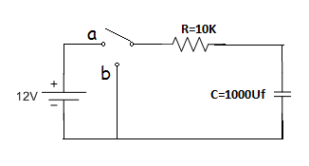
If switch is connected to ‘a’, charging of capacitor takes place.
If switch is connected to ‘b’, discharging of capacitor takes place.

OBSERVATION TABLE:

CHARGING OF CAPACITOR |  |  |  | DISCHARGING OF CAPACITOR
Sr.No. | Time  t  Sec. | Voltage V_{c}  Volt | Current  I  mA | Sr.No. | Time  t  Sec. | Voltage V_{c}  Volt | Current  I  mA

CALCULATION:

CONCLUSION:

EXPERIMENT NO: 5 DATE: / / 20

AIM: To study the I-V characteristics of a p-n junction diode

COMPONENTS: Power Supply (0-20V), Voltmeter (0-30V), Ammeter (μA & mA range), Kit of EDkits, connecting wires.

THEORY:

A PN Junction Diode is one of the simplest Semiconductor Devices around, and which has the characteristic of passing current in only one direction only. However, unlike a resistor, a diode does not behave linearly with respect to the applied voltage as the diode has an exponential current-voltage ( I-V ) relationship and therefore we cannot described its operation by simply using an equation such as Ohm’s law.
If a suitable positive voltage (forward bias) is applied between the two ends of the PN junction, it can supply free electrons and holes with the extra energy they require to cross the junction as the width of the depletion layer around the PN junction is decreased.
By applying a negative voltage (reverse bias) results in the free charges being pulled away from the junction resulting in the depletion layer width being increased. This has the effect of increasing or decreasing the effective resistance of the junction itself allowing or blocking current flow through the diode.
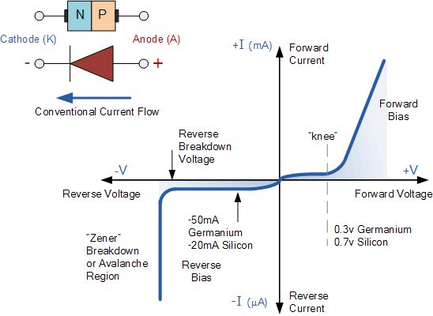

CIRCUIT DIAGRAMS:

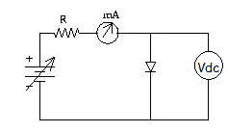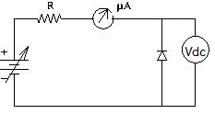
Fig: 5.1 forward biased diode Fig: 5.2 Reverse biased diode

PROCEDURE:
- Wire up the circuit shown in figure 5.1
- Record the voltage across the diode (V) and current (I) through it as a function of input voltage.
- Repeat the experiment of the reverse biased diode (fig 5.2).
- Plot I-V characteristics of diode.

OBSERVATION TABLE:

Forward Bias

SR NO | Supply Voltage  Vs | Voltage Across Diode  Vdc(V) | Current through Diode  Idc(mA)
1
2
3
4
5
6
7
8
9
10
11
12
13
14
15
Reverse Bias

SR NO | Supply Voltage  Vs | Voltage Across Diode  Vdc(V) | Current through Diode  Idc(µA)
1
2
3
4
5
6
7
8
9
10

CONCLUSION:

